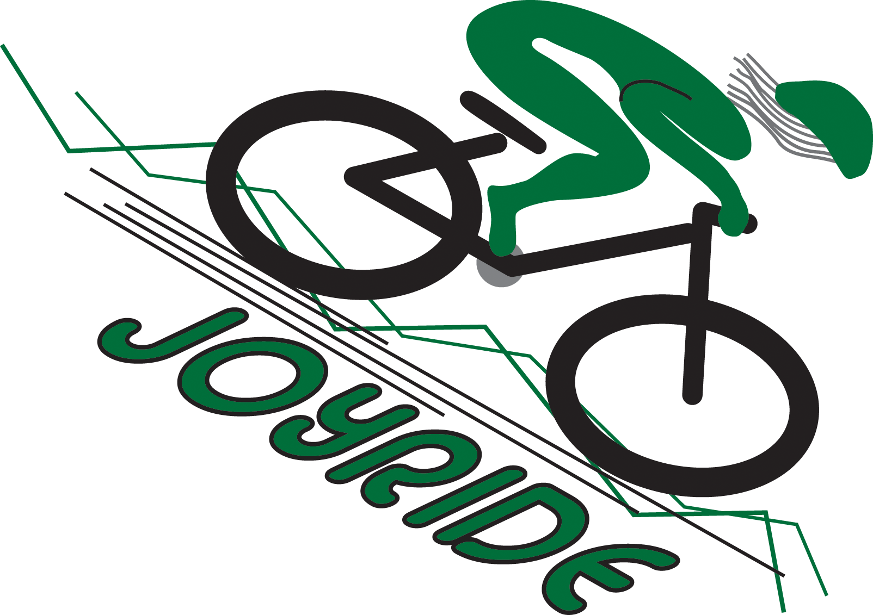
JOYRIDE MOUNTAIN BIKE
CLINICS
www.joyridemtb.com
INSTRUCTIONAL AID

1.) PROPER BODY POSITION
Understanding the proper positioning for aggressive riding is fundamental. Everything starts at the proper body position.

Let’s start with your head. Your chin should be up and pointed about 15-20 ft down the trail. You always want to LOOK WHERE YOU ARE GOING, NOT AT YOUR FRONT WHEEL. Riding is so much easier if you remember this. It takes some training so don’t get frustrated, even I have to remind myself. Look UP!

Keep your shoulders relaxed and your elbows should be pointed out like you plan on using them to fly with. ELBOWS OUT. This gives you a lot of flexibility and control. Your arms are not NOODLES. It is like the fancy dancing where they have to keep a frame. You don’t want to be fully rigid, but instead work to maintain a framework with your elbows pointed out.
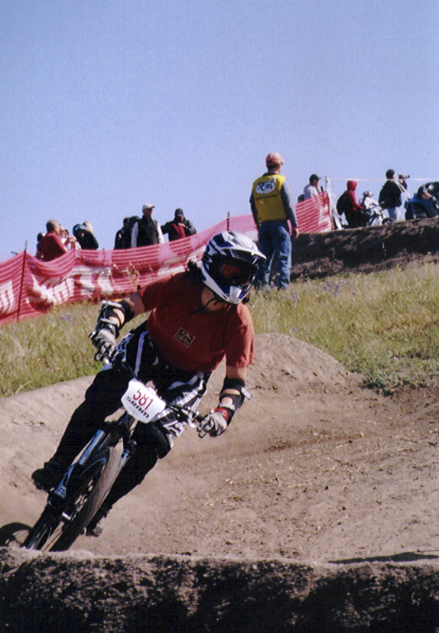
Your hips should be tucked in; you don’t want your backside to be sticking out. This is a very subtle movement, but changes your center of gravity. This moves your C.G. to the neutral/center position on your bike. This will give you more control while riding.

Your feet should be at the 3 and 9 o’clock positions and your knees should be bent and pointed out. Depending on the steepness of the trail will dictate how far bent your knees are. Of course we are not sitting on our seat during this. I will demonstrate.
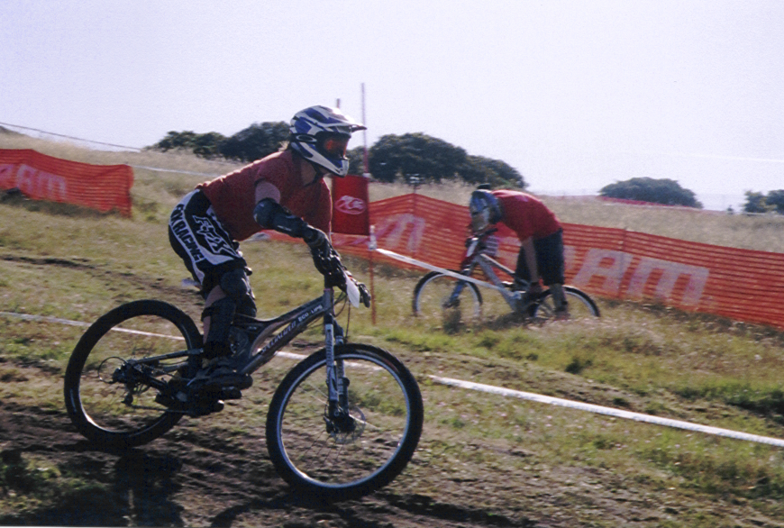

2.) GET TO KNOW YOUR FRONT BRAKE
All your braking power and control is in your front brake. You just need to make friends with it and get to know it. Do not be afraid of it. Any easy way to start is to pedal on flat ground and get a little bit of speed. Brake and you should feel your front suspension compress. As the front suspension compresses your upper body is going to want to move forward. This is where the proper body position comes in. With your elbows OUT you can push back off of the handlebars to return to your neutral position. Try this faster and faster till you feel very comfortable using your front brakes. This also helps get familiar with how much pressure needs to be applied and the resulting braking force. I will demonstrate this and have everyone practice.
3.) PROPER SHIFTING
There some combinations of gears that are not designed to be compatible. The smallest gear in front and back is a no, no and same goes for the biggest gear in front and back. There are combinations of other gears that are m,,,,uch better. By using both the big gears you are stretching the chain out and stressing the components. For technical descents you should be in your middle ring in the front and probably 3-6 in the back depending on the level of technicality.

Always shift into the low gears before you start climbing up a hill. This is much easier on your drive train and will keep it healthy longer.
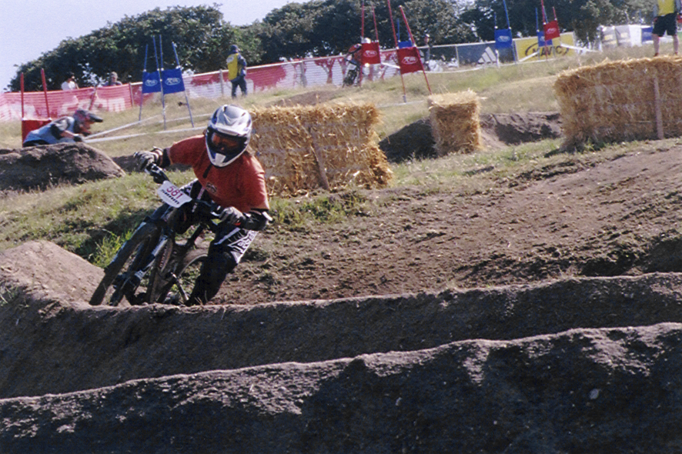

4.) CORNERING- SWITCHBACKS
When entering a corner or switchback you always want to take advantage of the entire trail. Use the outside line to begin and then come in. Starting with the proper body position then lean into the corner/switchback with the inside leg leaned toward the corner. We will practice some really good drills to demonstrate this technique.

When you turn you actually want to lean as opposed to turning. Most turns can be accomplished with just a lean to one side without actually having to turn the bike. Again this starts with the proper body position and lean into the corner. If it is bermed and you have enough speed you won’t need to brake. This takes practice, but is good technique once you learn it.

5.) TECHNICAL DESCENTS
The key to technical descents is trusting your bike. With 4 plus inches of travel on mountain bikes nowadays they can do almost anything. Maintain the proper body position, look down the trail about 20ft knowing your bike will handle the bumps and pick your line. Because the bikes are so good today I usually just point and go and let the bike do all the work. I maintain my “center” position. As the trail gets steeper my center of gravity is going to start to move toward the rear of the bike. When entering the technical section you don’t want to be too far back because you won’t have the control you need. So find the center position and maintain it.

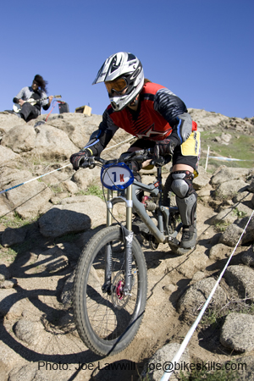
In this picture I am looking down the trail and letting my bike do all the work. I am a little low to keep my center of gravity low making it easier to control the bike.

6.) DROPS AND JUMPS
I don’t feel comfortable trying to give instructions in a pamphlet on these subjects so come to a clinic and we will chat more.

To find out more cool tips join me at one of my clinics and on my JOYRIDES, Tuesday evenings, coming this summer to a park near you. Check it out at www.joyridemtb.com

